Animals

Sing along and dance: https://www.youtube.com/watch?v=Ryb-Gsxgpgk
This is a frog. It can jump.
jump run fly swim climb

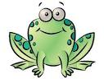 | 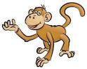
This is a frog .  It can jump . | This is a …………….……….. .  It can ………………………. | This is a ……………………….. .  It can ……………………….
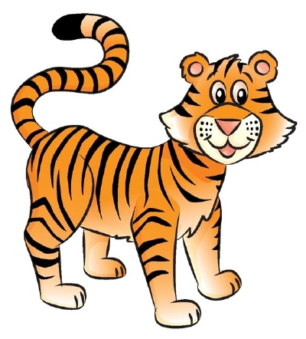 | 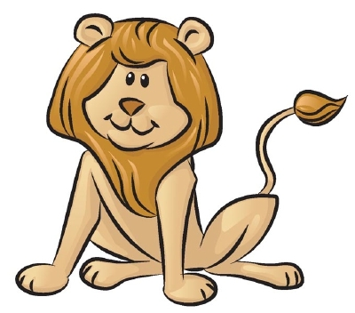 | 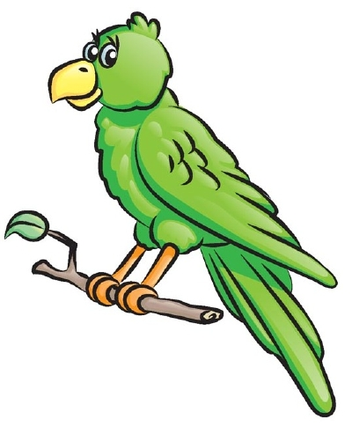
This is a ……………..……… .  It can ………………………. | This is a …………………… .  It can ………………………. | This is a ………….………….. .  It can ……………………….
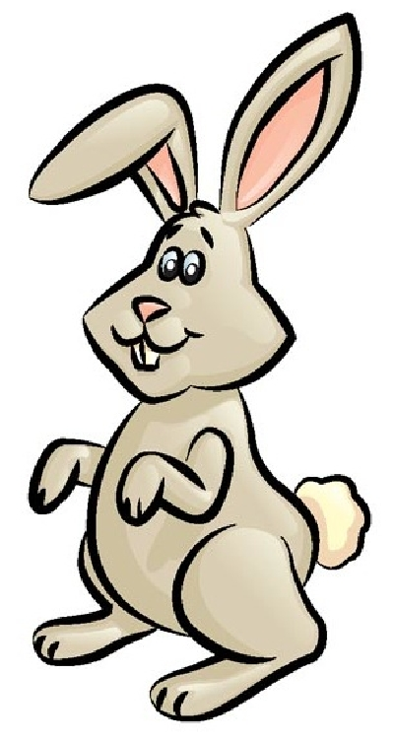 | 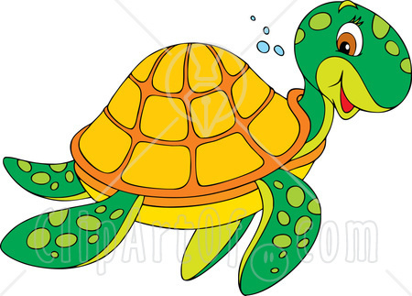 | 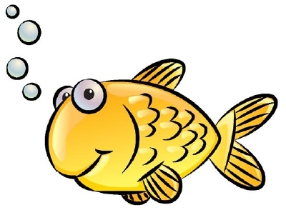
This is a ……………..…… .  It can ………………………. | This is a ……………..……. .  It can ……………………….. | This is a …………………… .  It can ……………………….

turtle frog fish tiger bird
rabbit lion monkey dolphin

This is a frog. It can jump.
jump run fly swim climb

This is a frog .  It can jump . | This is a monkey.  It can climb. | This is a dolphin .  It can swim.
This is a tiger.  It can run. | This is a lion.  It can run. | This is a bird.  It can fly.
This is a rabbit .  It can jump. | This is a turtle.  It can swim. | This is a fish .  It can swim.

turtle frog fish tiger bird
rabbit lion monkey dolphin

